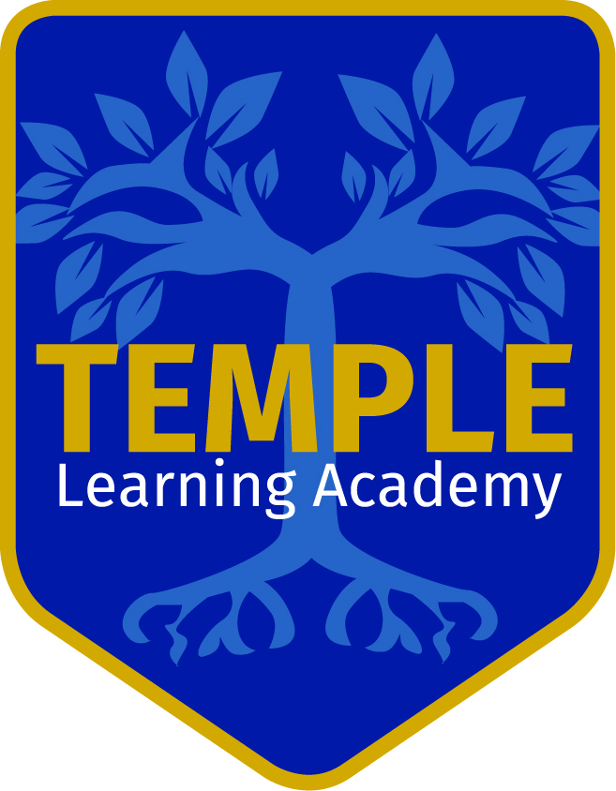
Read Write Inc and Oxford Reading Tree Correlation Chart
As your pupils get assessed and moved you should be matching their progress in phonics with progress through the reading scheme.

Read Write Inc.   | Spelling patterns | PNS Framework for Literacy  reference | ORT stages and titles with Group Activity Sheets for these objectives  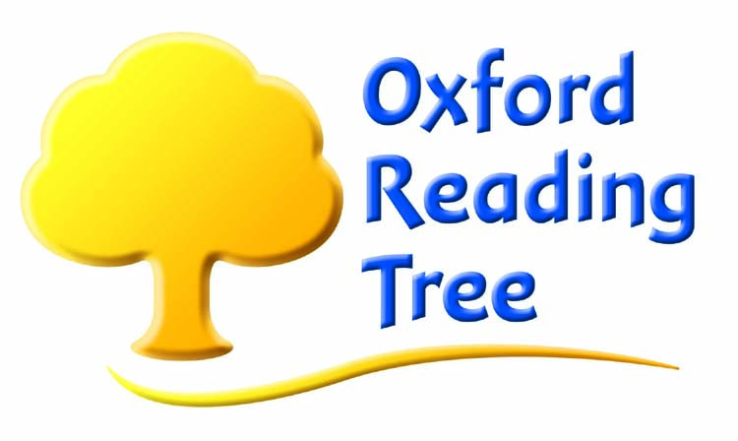 | Book  Colour Band  Movement should be gradual
Ditties pages  1-12 | CVC words including  th, sh, ch | Foundation stage 5  Explore and experiment with sounds words and texts  Hear and say sounds in words in the order in which they occur  Blend CVC words and recognise common digraphs  Link sounds to letters, naming and sounding letters of the alphabet | Stage 1: At School (Bk1 p14)  The Lost Teddy (Bk1 p18)  First Words: Who Is It? (Bk1 p26)  Stage 1+ Patterned stories:  Good Old Mum (Bk1 p38)  Fancy Dress (Bk1 p42)  The Pet Shop (Bk1 p46) | 1  Pink
Ditties pages  13-42  Ditty books | CVC words including  th, sh, ch  Initial consonant blends  sp, fl, sl, cr, dr  Word endings  -ss, -ll, -ck, -nk, -ve | Foundation stage: 5  Link sounds to letters, naming and sounding letters of the alphabet  Explore and experiment with sounds, words and texts  Hear and say sounds in words in the order in which they occur  Blend CVC words and recognise common digraphs  Use their phonic knowledge to read simple regular words and make phonetically plausible attempts at longer and more complex words | Stage 1+ First Phonics story books  Stage 2 The Toys’ Party (Bk1 p62)  Stage 3 A Cat in the Tree (Bk1 p98)  Stage 3 The Rope Swing (Bk1 p102)  (-ng and –ing)  Assessment Y1T2 (Bk2 p49) | 2  Red
Stories Set 1 Green | Short vowels  Consonants  +th, sh, ch  Double consonants  ff ll  Final consonants  –ng, -ck, -nk -tch | Foundation stage: 5  Link sounds to letters, naming and sounding letters of the alphabet  Explore and experiment with sounds words and texts  Hear and say sounds in words in the order in which they occur  Blend CVC words and recognise common digraphs  Use their phonic knowledge to read simple regular words and make phonetically plausible attempts at longer and more complex words  Y1: 5  Read automatically high frequency words  Use phonics to read unknown or difficult words | Stage 2 First Phonics story books  Stage 3 First Phonics story books  Stage 3The Rope Swing (Bk1 p102)  (-ng and –ing) | 3  Yellow
Stories Set 2 Purple | Short vowels  Consonants  + th, sh, ch  Double consonants,  tt, ll, ff, ss, zz  Final consonants  -ck, -nk, -ng,  Initial blends  tr, st, bl, sp, sw, bl, fr, fl, cr, spl | Foundation stage: 5  Blend CVC words and recognise common digraphs  Use their phonic knowledge to read simple regular words and make phonetically plausible attempts at longer and more complex words  Year 1 5:  Use phonics to read unknown or difficult words  Recognise all common digraphs  Read automatically high frequency words | Stage 3 A Cat in the Tree (Bk1 p98)  Assessment Stage 4 Y1T2 (Bk2 p48)  Stage 4 The Storm (Bk2 p32)  Assessment Stage 4 Y1T2 (Bk2 p49, 51)  Assessment stage 4 Y1 T2 (Bk2 p50)  Stage 4 The Play (Bk2 p28) | 4  Blue
 | Spelling patterns | PNS Framework for Literacy  reference |  | Book Band
Ditties pages  45-54  Stories Set 3 Pink | Double consonants  tt, ll, ff, mm, pp,  Final consonants  -ve, -ng, -nk, -ck, -tch  long vowels:  ay, ee, igh, ow, oo,  ar, ow, oy  root word with  –ing, -ed, -s  syllables | Year 1: 5  Recognise all common digraphs and trigraphs, including more complex long vowel phonemes  Read automatically high frequency words  Use syntax and context to self-correct when reading for accuracy and meaning  Read longer words including two- and three-syllable words | Stage 4 The Storm (Bk2 p32)  Stage 5 The Dragon Tree (Bk2 p62)  Village in the Snow (Bk2 p74)  Stage 5 Gran (Bk2 p66) | 5  Green
Stories Set 4 Orange | Long vowels  ay, ee, igh, ow, ue,  oo, ar, ou, oy  or, air, ir,  root word with  -ing, -ed, -s  syllables | Year 2: 5  Recognise less common digraphs and trigraphs, exploring word families  Routinely apply phonic knowledge for reading unknown or difficult words  Use syntax, context and word structure when reading for meaning  Use knowledge of word structure to support reading, including polysyllabic words | Stage 6 In the Garden (Bk3 p16)  Stage 6 Kipper and the Giant (Bk3 p20)  Stage 6 Land of the Dinosaurs (Bk3 p28) | 6  Orange
Stories Set 5 Yellow | Long vowel sounds  ay, ee, igh, ow, oo  compound words  syllables | Year 2 5  Recognise less common digraphs and trigraphs, exploring word families  Routinely apply phonic knowledge for reading unknown or difficult words  Use knowledge of word structure to support reading, including polysyllabic words | Stage 6 In the Garden (Bk3 p16)  Stage 7 Lost in the Jungle (Bk3 p50)  Stage 7 The Broken Roof (Bk3 p54) | 7  Turquoise
Stories Set 6 Blue | Long vowel sounds  ay, ee, igh, ow, ue  air, or, ir,  oy, ar,  compound words  syllables  suffixes –ing, -ed, s for plurals | Year 2 5  Recognise less common digraphs and trigraphs, exploring word families  Routinely apply phonic knowledge for reading unknown or difficult words  Use knowledge of word structure to support reading, including polysyllabic words  Use syntax, context and word structure when reading for meaning | Stage 6 In the Garden (Bk3 p16)  Stage 7 Red Planet (Bk3 p46)  Stage 7 Lost in the Jungle (Bk3 p50)  Stage 7 The Broken Roof (Bk3 p54) | 8  Purple
Stories Set 7 Grey | ay, igh, oo, ow, ue,  air, or, ir  ear,  ire, -ture, -ure, our, tion, tious, cious, able, ible  syllables  suffixes: ing, ed, s for plurals,  ly,  er, est, y, | Year 2 5  Recognise less common digraphs and trigraphs, exploring word families  Routinely apply phonic knowledge for reading unknown or difficult words  Use knowledge of word structure to support reading, including polysyllabic words  Use syntax, context and word structure when reading for meaning | Stage 9 The Quest (Bk3 p116)  Stage 9 Survival Adventure (Bk3 p120)  Stage 8 A Day in London (Bk3 p92)  Stage 8 Viking Adventure (Bk3 p80)  Stage 9 The Litter Queen (Bk3 p112)  Stage 8 The Flying Carpet (Bk3 p88) | 9  Gold

