

Pensans School

“Eighty Eight Club”

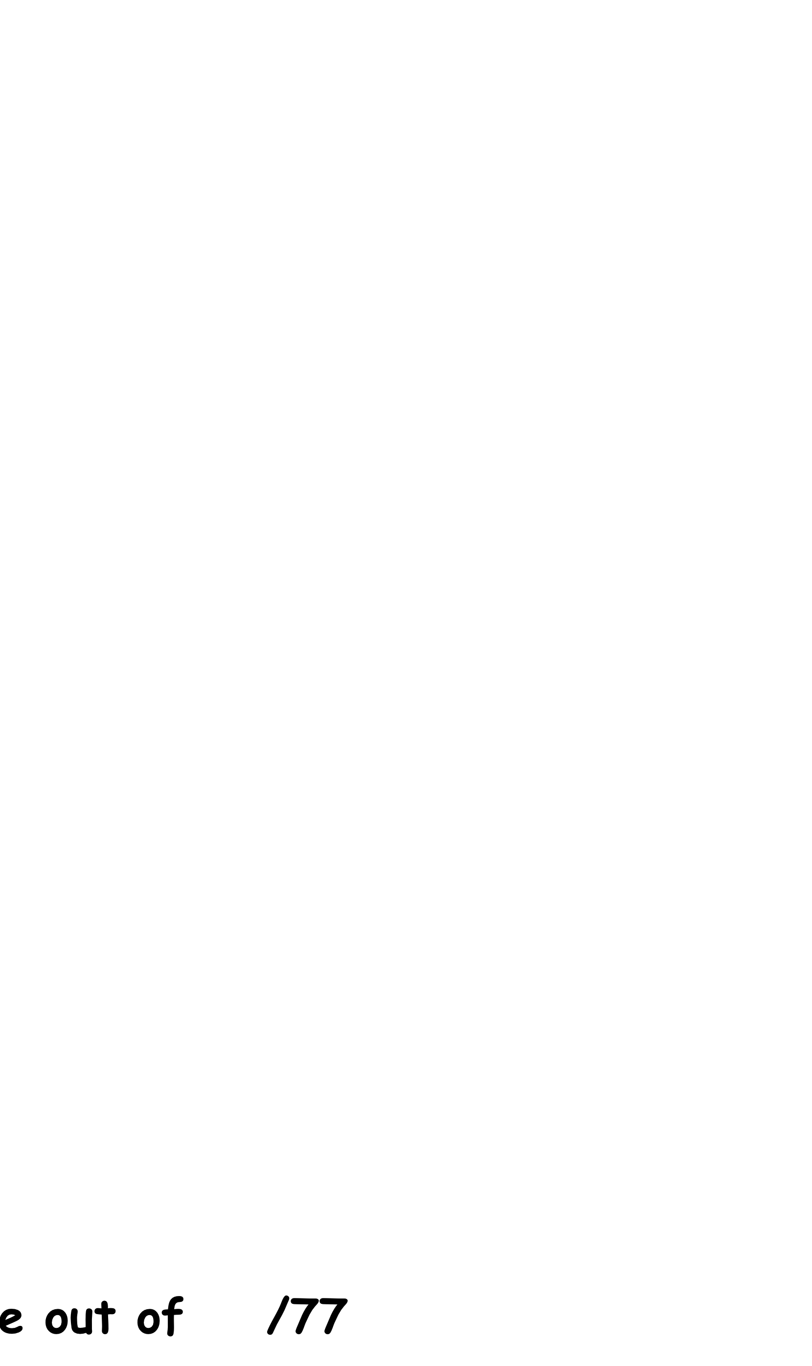

PRACTICE

Updated Summer 2017

|  |  |  |
| --- | --- | --- |
| 1 | 7 x | 7 |
| 2 | x 9 | 81 |
| 3 | = | 7 x 1 |
| 4 | 90 ÷ 10 |  |
| 5 | ÷ 6 | 24 |
| 6 | 2 x 0 |  |
| 7 | 7 x | 14 |
| 8 | 3 x | 18 |
| 9 | 81 ÷ | 9 |
| 10 | 10 ÷ | 2 |
| 11 | 6 x 8 |  |
| 12 | 7 x 3 |  |
| 13 | x 4 | 16 |
| 14 | 8 x | 8 |
| 15 | 21 ÷ | 3 |
| 16 | 2 x 0 |  |
| 17 | = | 9 x 4 |
| 18 | 9 x 6 |  |
| 19 | ÷ 4 | 7 |
| 20 | 4 x 5 |  |
| 21 | ÷ 2 | 8 |
| 22 | 3 x 8 |  |
| 23 | 5 x 7 |  |
| 24 | 63 ÷ | 9 |
| 25 | 2 x 1 |  |
| 26 | 9 x 5 |  |
| 27 | 8 x | 24 |
| 28 | 4 x 7 |  |
| 29 | 3 x 8 |  |
| 30 | 5 x | 5 |

|  |  |  |
| --- | --- | --- |
| 31 | 5 x 6 |  |
| 32 | 8 x 4 |  |
| 33 | 18 ÷ | 2 |
| 34 | ÷ 10 | 6 |
| 35 | 9 x 8 |  |
| 36 | x 8 | 32 |
| 37 | 8 x 5 |  |
| 38 | 4 x 8 |  |
| 39 | 6 x 0 |  |
| 40 | 3 x 10 |  |
| 41 | 7 x 5 |  |
| 42 | = | 3 x 0 |
| 43 | 5 x 5 |  |
| 44 | 5 x 10 |  |
| 45 | ÷ 3 | 7 |
| 46 | 2 x 8 |  |
| 47 | ÷ 9 | 5 |
| 48 | 2 x 7 |  |
| 49 | 6 x 1 |  |
| 50 | 4 x 10 |  |
| 51 | 8 x | 80 |
| 52 | 3 x 1 |  |
| 53 | 5 x 4 |  |
| 54 | 2 x 6 |  |
| 55 | 7 x 6 |  |
| 56 | x 5 | 10 |
| 57 | 8 x 7 |  |
| 58 | 3 x 2 |  |
| 59 | = | 4 x 0 |

|  |  |  |
| --- | --- | --- |
| 60 | x 2 | 12 |
| 61 | 7 x 7 |  |
| 62 | 15 ÷ | 5 |
| 63 | 2 x 7 |  |
| 64 | ÷ 8 | 8 |
| 65 | 3 x 3 |  |
| 66 | 9 x | 18 |
| 67 | 6 x 3 |  |
| 68 | 5 x 12 |  |
| 69 | 7 x 8 |  |
| 70 | 4 ÷ | 0 |
| 71 | 2 x 0 |  |
| 72 | 8 x 9 |  |
| 73 | 3 x | 12 |
| 74 | 10 x 4 |  |
| 75 | 5 x 9 |  |
| 76 | = | 9 x 1 |
| 77 | 4 x 12 |  |
| 78 | ÷ 2 | 20 |
| 79 | 6 x 5 |  |
| 80 | 7 x 9 |  |
| 81 | 3 x 5 |  |
| 82 | 36 ÷ | 6 |
| 83 | 4 x 3 |  |
| 84 | 9 x 0 |  |
| 85 | 5 x 8 |  |
| 86 | ÷ 10 | 2 |
| 87 | 2 x 3 |  |
| 88 | 9 x 11 |  |

Score / 88