45 | x 2 | 24
46 | x 7 | 42
47 | 4 x 9
48 | 4 x 8
49 | 3 x 1
50 | x 7 | 35
51 | 10 x 2
52 | 5 x 5
53 | 9 x | 63
54 | 8 x 8
55 | 6 x 6
56 | 4 x 9
57 | 10 x | 110
58 | 6 x 9
59 | 5 x 8
60 | 10 x 9
61 | 6 x | 60
62 | 2x 7
63 | 4 x 11
64 | 10 x 12
65 | 11 x 8
66 | 2 x 11

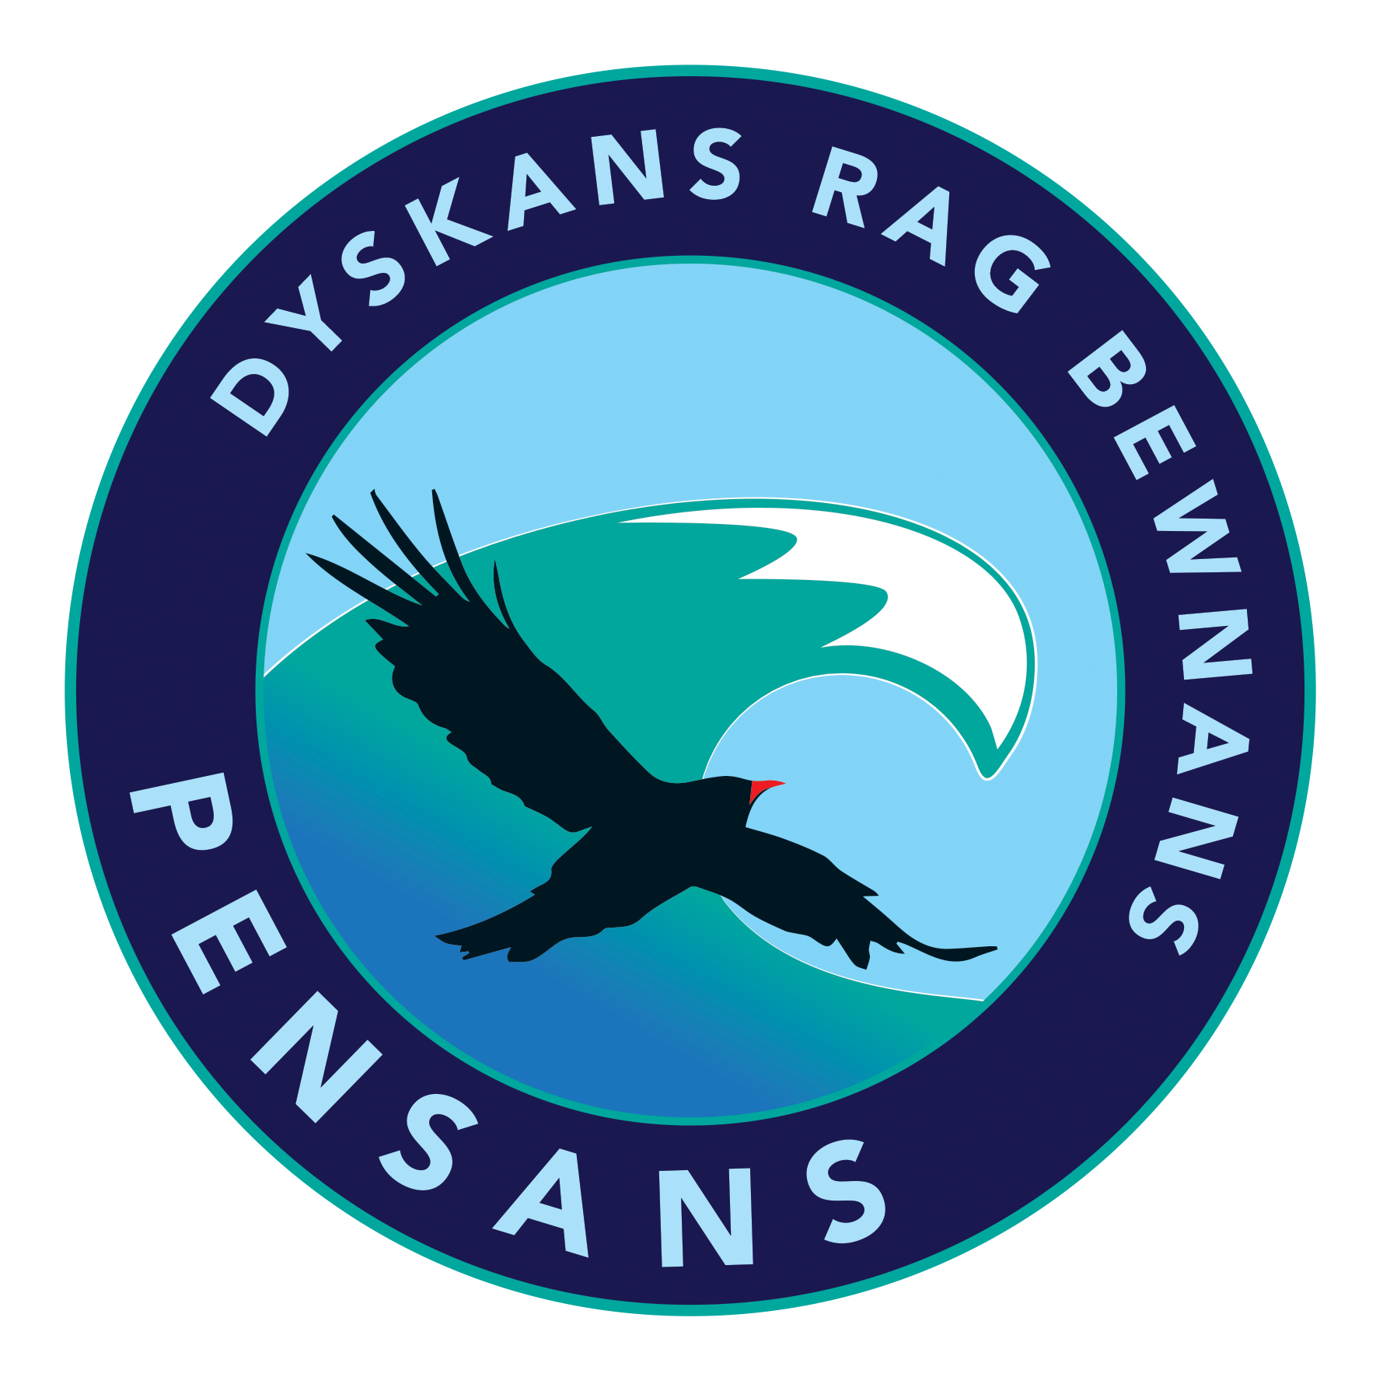
Pensans School
“Sixty Six Club”

PRACTICE SHEET
23 | x 9 | 72
24 | 3 x 7
25 | 2 x | 8
26 | 6 x 7
27 | 12 x | 36
28 | 10 x 6
29 | 6 x 4
30 | 3 x | 27
31 | 4 x | 40
32 | 11 x 2
33 | 7 x 2
34 | 2 x | 16
35 | 4 x 6
36 | 6 x 0
37 | x 5 | 15
38 | 10 x 10
39 | 5 x | 10
40 | 2 x 2
41 | 6 x 1
42 | 10 x 1
43 | 9 x 9
44 | 3 x | 24

1 | 9 x 2
2 | x 10 | 40
3 | 4 x | 28
4 | x 2 | 6
5 | 10 x 0
6 | 6 x 2
7 | 6 x 6
8 | 4 x | 16
9 | 3 x | 36
10 | 3 x 2
11 | x 5 | 50
12 | 2 x 9
13 | x 3 | 12
14 | 3 x 7
15 | 5 x | 35
16 | x 0 | 2
17 | 9 x 11
18 | 7 x 8
19 | x 2 | 24
20 | 6 x 9
21 | 5 x | 55
22 | x 5 | 60

Score / 66
Updated Summer 2017

