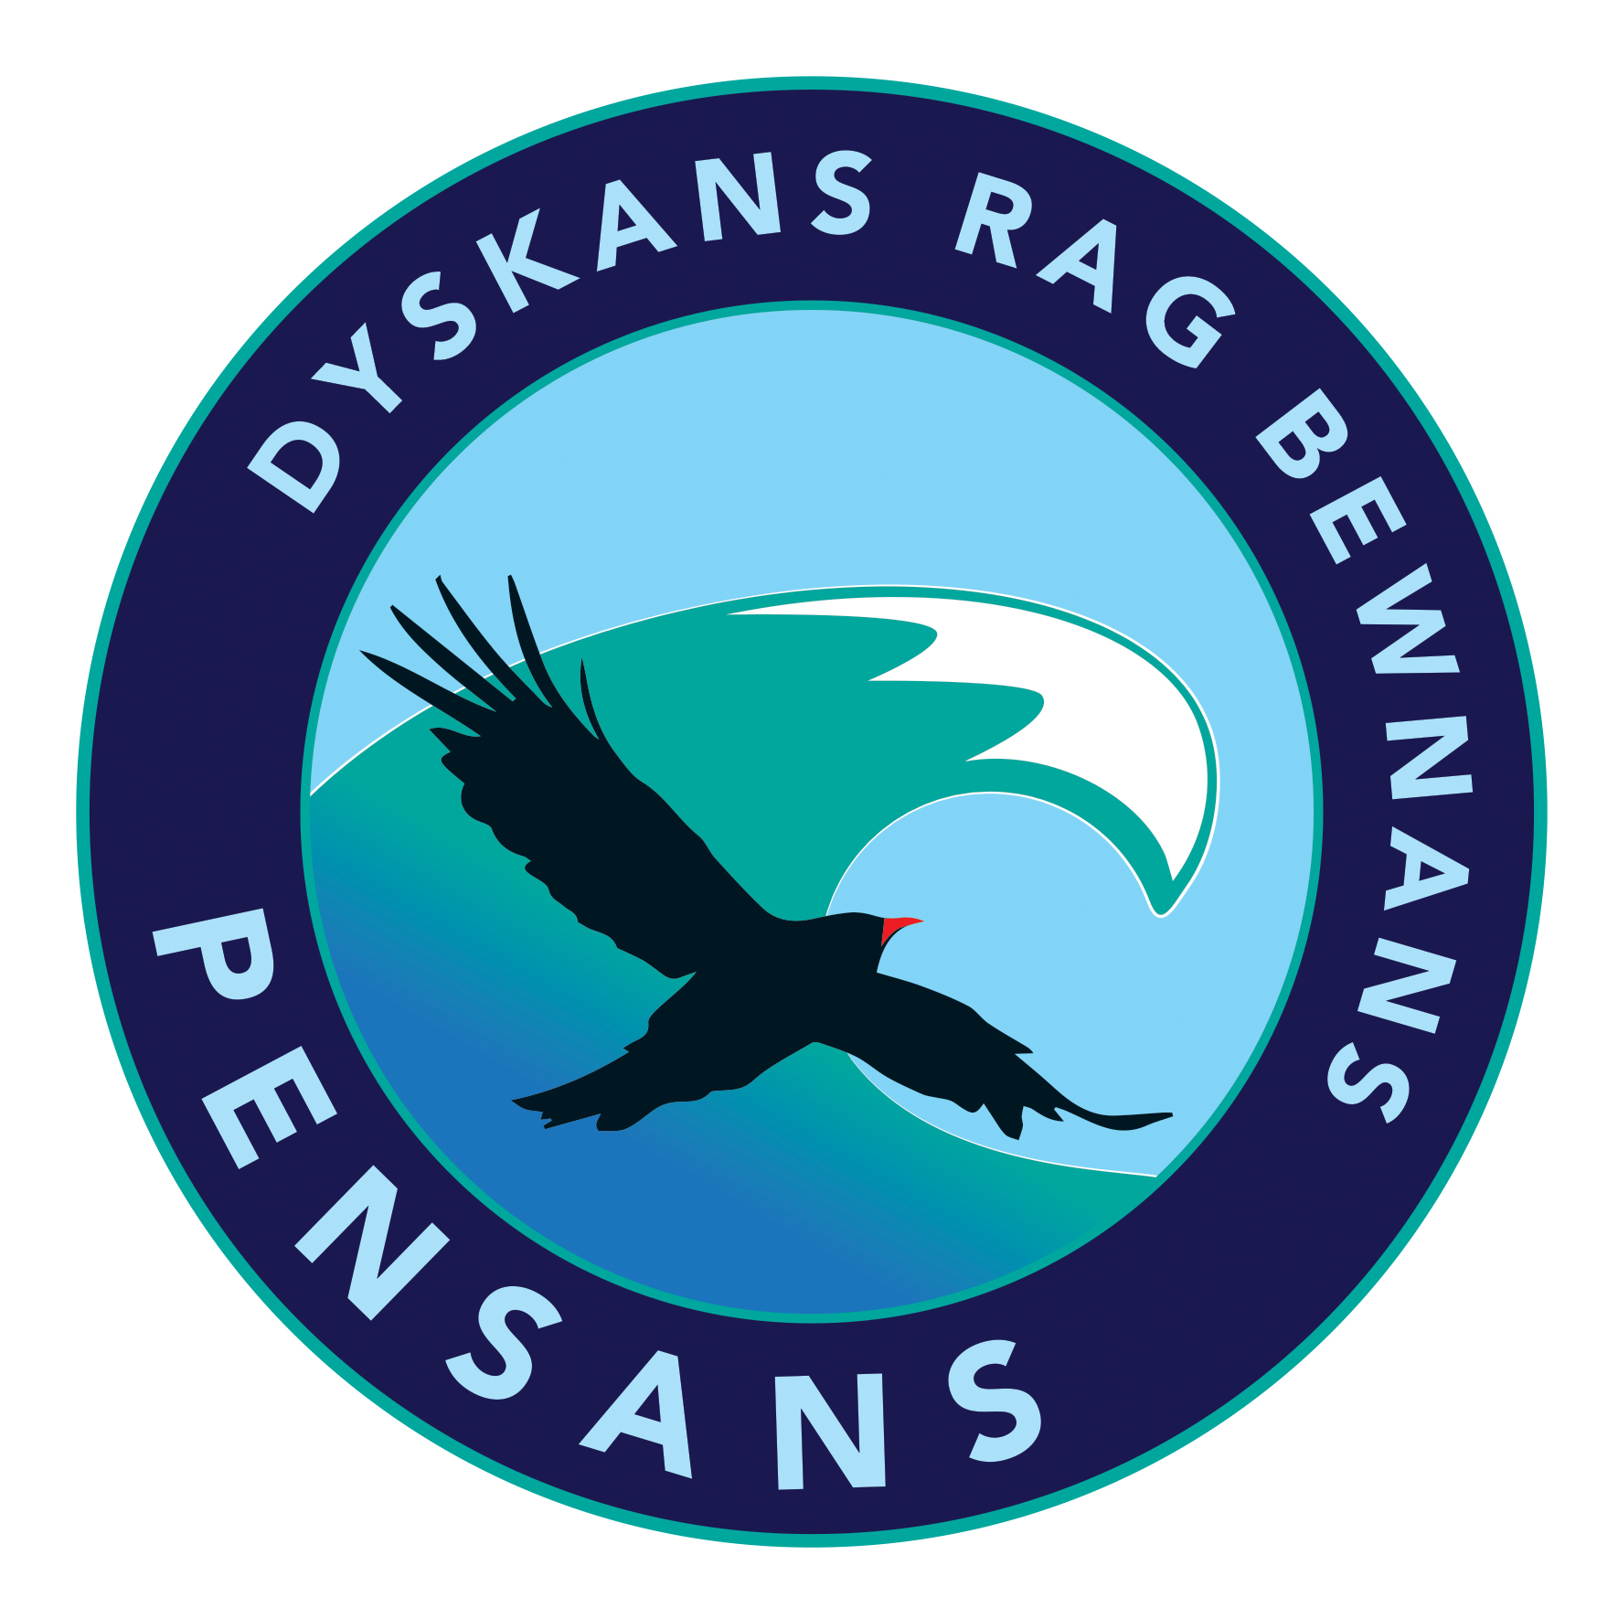

Pensans School

“Silver Club”

Practice

**Name:**

|  |  |  |
| --- | --- | --- |
| 1 | 56 ÷ 8 |  |
| 2 | 7 x 5 |  |
| 3 | 20 ÷ 2 |  |
| 4 | 36 ÷ 6 |  |
| 5 | 50 ÷ 5 |  |
| 6 | 64 - 39 |  |
| 7 | 61 + 99 |  |
| 8 | 2 x 4 |  |
| 9 | 34 + 92 |  |
| 10 | 7 x 9 |  |
| 11 | 63 + 78 |  |
| 12 | 5 x 8 |  |
| 13 | 12 ÷ 6 |  |
| 14 | 14 ÷ 2 |  |
| 15 | 4 x 6 |  |
| 16 | 24 ÷ 6 |  |
| 17 | 91 + 24 |  |
| 18 | 6 x 12 |  |
| 19 | 132 ÷ 11 |  |
| 20 | 4 x 8 |  |
| 21 | 7 x 12 |  |
| 22 | 10 x 4 |  |
| 23 | 40 ÷ 5 |  |
| 24 | 45 ÷ 5 |  |
| 25 | 4 x 9 |  |
| 26 | 9 x 5 |  |
| 27 | 3 x 5 |  |
| 28 | 77 - 43 |  |
| 29 | 6 x 9 |  |
| 30 | 6 x 1 |  |
| 31 | 28 ÷ 4 |  |
| 32 | 90 ÷ 9 |  |
| 33 | 8 x 9 |  |

|  |  |  |
| --- | --- | --- |
| 34 | 96 ÷ 12 |  |
| 35 | 6 x 7 |  |
| 36 | 5 x 4 |  |
| 37 | 108 ÷ 12 |  |
| 38 | 34 + 72 |  |
| 39 | 61 - 32 |  |
| 40 | 8 x 4 |  |
| 41 | 73 - 54 |  |
| 42 | 121 ÷ 11 |  |
| 43 | 10 ÷ 2 |  |
| 44 | 53 + 89 |  |
| 45 | 36 ÷ 9 |  |
| 46 | 33 ÷ 11 |  |
| 47 | 33 ÷ 11 |  |
| 48 | 60 ÷ 5 |  |
| 49 | 8 x 5 |  |
| 50 | 5 x 3 |  |
| 51 | 40 ÷ 4 |  |
| 52 | 10 x 10 |  |
| 53 | 2 x 6 |  |
| 54 | 73 - 44 |  |
| 55 | 70 ÷ 7 |  |
| 56 | 8 x 11 |  |
| 57 | 16 ÷ 2 |  |
| 58 | 8 x 3 |  |
| 59 | 74 + 46 |  |
| 60 | 25 ÷ 5 |  |
| 61 | 99 + 72 |  |
| 62 | 2 x 2 |  |
| 63 | 12 ÷ 3 |  |
| 64 | 5 x 7 |  |
| 65 | 10 x 2 |  |
| 66 | 64 ÷ 8 |  |

|  |  |  |
| --- | --- | --- |
| 67 | 20 ÷ 4 |  |
| 68 | 32 + 48 |  |
| 69 | 18 ÷ 6 |  |
| 70 | 75 - 39 |  |
| 71 | 9 x 3 |  |
| 72 | 24 ÷ 12 |  |
| 73 | 6 x 11 |  |
| 74 | 21 ÷ 7 |  |
| 75 | 6 x 6 |  |
| 76 | 9 x 12 |  |
| 77 | 81 ÷ 9 |  |
| 78 | 9 x 9 |  |
| 79 | 70 - 21 |  |
| 80 | 99 ÷ 11 |  |
| 81 | 5 x 11 |  |
| 82 | 7 x 3 |  |
| 83 | 6 x 8 |  |
| 84 | 21 ÷ 3 |  |
| 85 | 3 x 1 |  |
| 86 | 6 x 2 |  |
| 87 | 16 ÷ 4 |  |
| 88 | 48 ÷ 12 |  |
| 89 | 6 x 5 |  |
| 90 | 3 x 9 |  |
| 91 | 8 x 8 |  |
| 92 | 44 ÷ 11 |  |
| 93 | 35 ÷ 5 |  |
| 94 | 10 x 9 |  |
| 95 | 48 ÷ 8 |  |
| 96 | 36 ÷ 12 |  |
| 97 | 85 + 42 |  |
| 98 | 8 x 6 |  |
| 99 | 60 ÷ 6 |  |
| 100 | 101 - 45 |  |