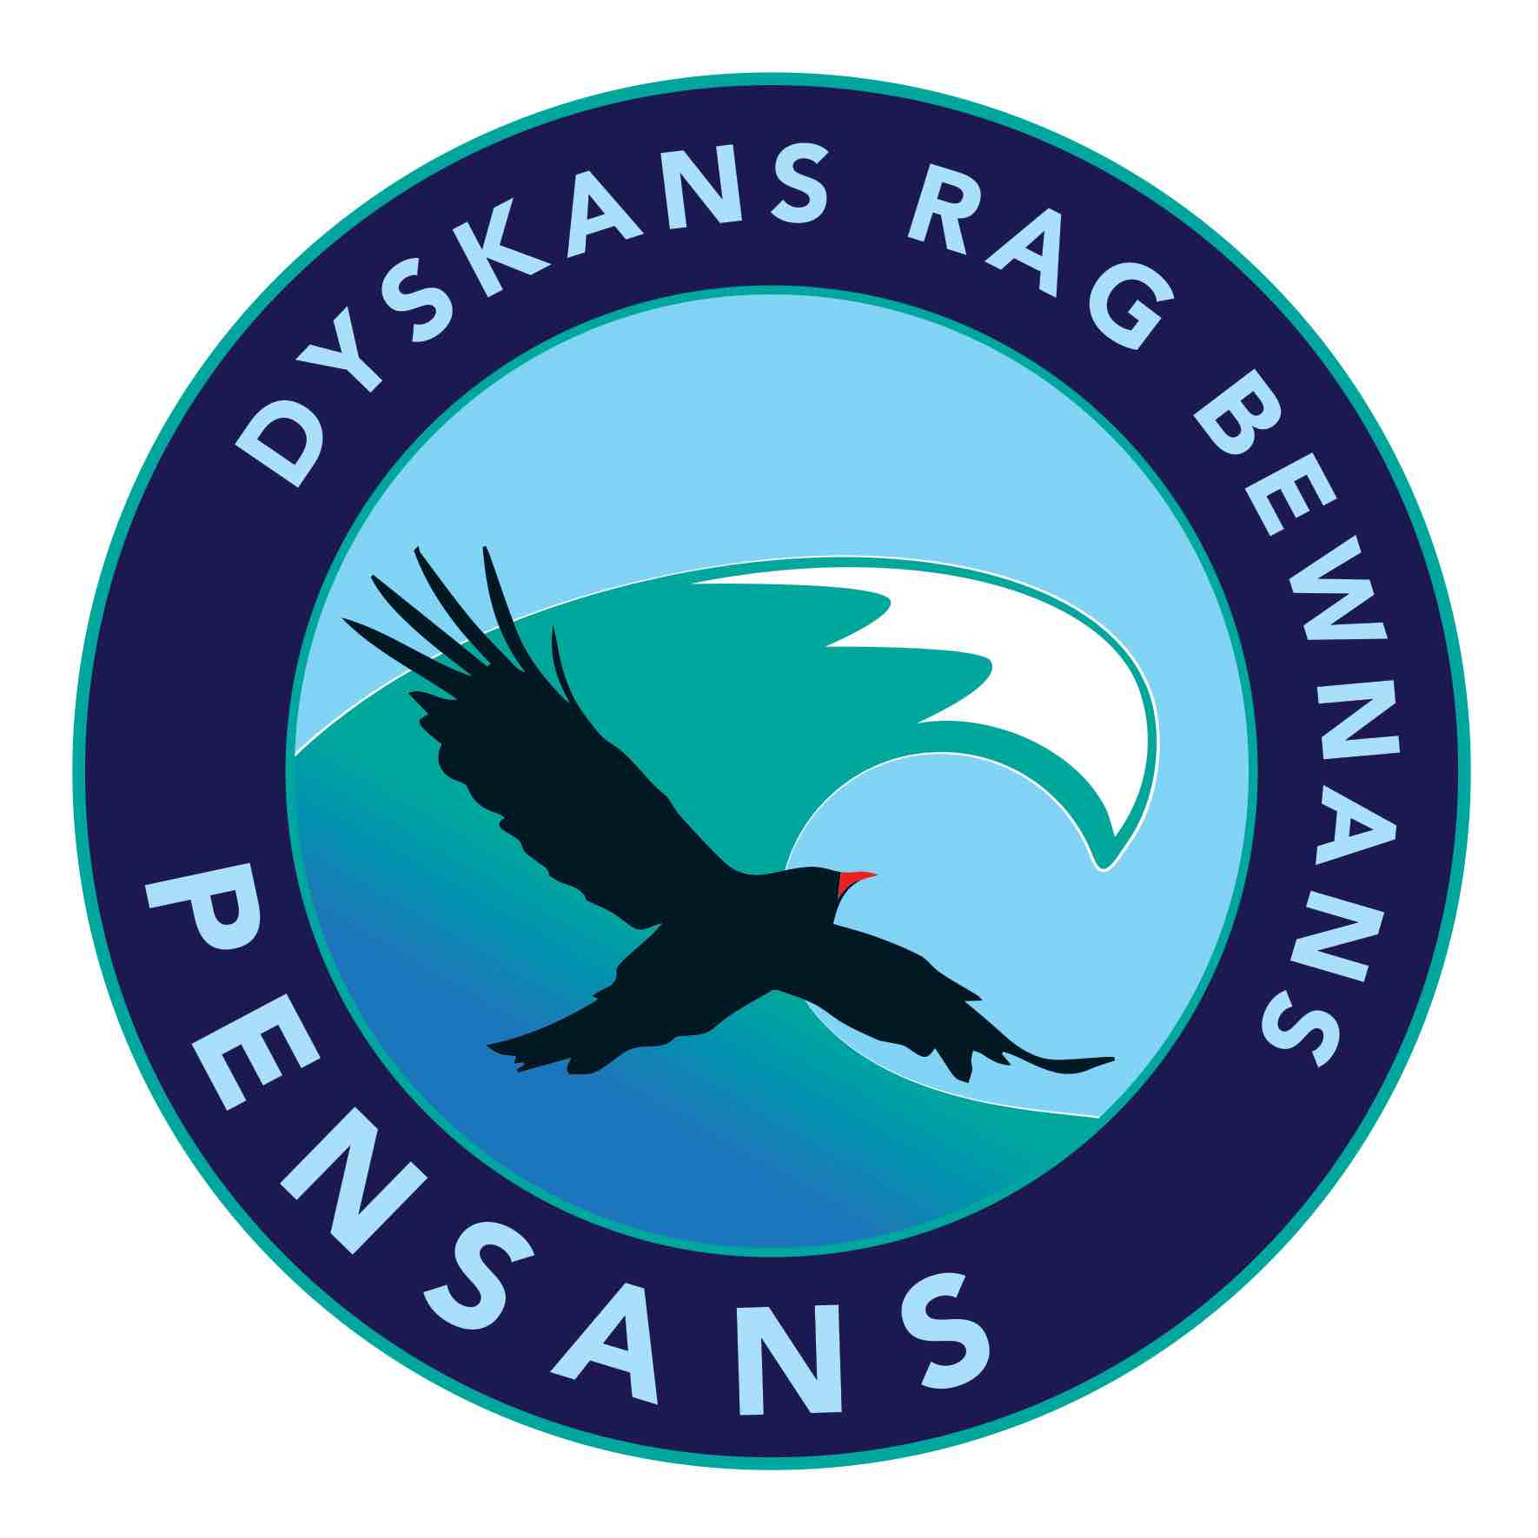

17.10.18
Dear Parent/Carer

Christmas Pantomime Visit

On Monday 10th December we are planning on taking the children to see the Christmas Pantomime at The Regal Theatre in Redruth. The show starts at 10.30 and we will be returning to school approx. 1pm. During this visit the children will watch the pantomime and get to meet Father Christmas. If you would like your child to attend the please pay the £10 charge on Parent Pay before Monday 3rd December.

Please make sure your child wears their school uniform and brings a coat. School will provide a packed lunch on this day.

If your child is likely to suffer from travel sickness please let the class teacher know.

Kind regards

Helen Smith

EYFS Leader

